# Order of Battle Widget

## Overview

The Order of Battle widget is a configurable tool for use with the WPF Runtime for ArcGIS Operations Dashboard application. The tool is designed to represent 2 feature classes in a hierarchical tree view defined in the underlying feature class’ schema. While designed for use with Esri Military Overlay schema in mind it is configurable for use with other feature classes that adhere to a similar schema.

A typical workflow is to display a military order of battle and equipment owned by units in the order of battle. The military overlay feature template provides the necessary schema for displaying force elements and equipment and will be used as an example. In the case of force elements two fields are used to define the hierarchy:

|  |  |
| --- | --- |
| **Force Element** | |
| **Field** | **Type** |
| UNIQUEDESIGNATION | String |
| HIGHERFORMATION | String |

|  |  |
| --- | --- |
| **Equipment** | |
| **Field** | **Type** |
| UNIQUEDESIGNATION | String |
| OWNINGUNIT | String |

While not strictly enforced, the UNIQUEDESIGNATION attribute of each feature in the feature class (Force Element or Equipment) should be an unique string value (if 2 or more features have the same UNIQUEDESIGNATION only one element with that value will be displayed in the Order of Battle tree view). The HIGHERFORMATION attribute of a force element should be the value of the UNIQUEDESIGNATION of its immediate parent unit. Therefore it will point to the UNIQUEDESIGNATION of another feature in the force element’s own feature class. In the case of equipment, the OWNINGUNIT, points to the UNIQUEDESIGNATION of a feature in a force element feature class. When the user configures an order of battle he will be prompted to supply a data source for both forces and equipment. As long as the data sources referenced by the Order of Battle widget adhere to a similar schema (field names do not need to be the same), the tool will build the Order of Battle tree view.

## Configuration

### Preparing the Map Widget

The first step in configuring a new Order of Battle is to access an operation view containing a map widget in an Operations Dashboard in configuration mode. The map widget should contain an ArcGIS Online or ArcGIS for Portal webmap. The webmap should contain the layers that will be represented in the Order of Battle. Each layer should be configured as dynamic. Also, the widget works best if the Operations Dashboard’s layer refresh is set a number <= 2. Once the map widget has been configured the user is ready to create and configure an order of battle.

### Creating and Configuring the Order of Battle Widget

#### Adding the Order of Battle widget

With a map widget created, you will need to make sure your Order of Battle widget is available to be added to your dashboard. To do this use the following steps.

1. Make sure you can edit your view, by clicking Tools > Edit Operation View. 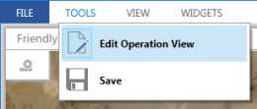
2. Click Widgets > Manage Add-Ins. 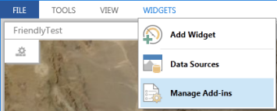
3. In the Manage Add-Ins window, click Add. 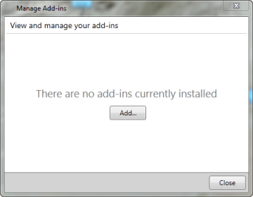
4. In the Choose Add-Ins window, use the Search box to locate the widget on your portal. 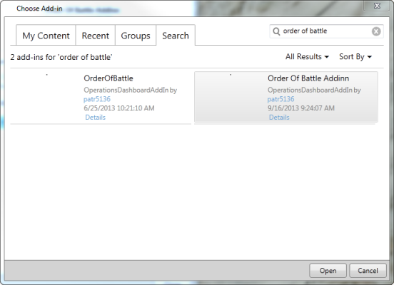
5. Click Open.
6. Click Close.
7. Click Widgets > Add Widget. 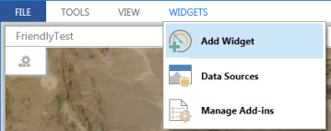
8. In the Add Widget window, click the Order of Battle widget. 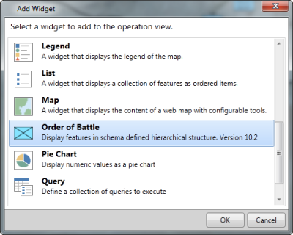
9. Click OK.

#### Creating the Order of Battle and configuring the widget

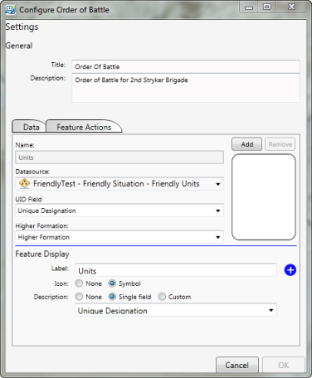

1. Type a title for your Order of Battle
2. Add an optional description
3. Select a datasource from the list of layers in the webmap.
4. Type a name representing the datasource. The first data source added to the Order of Battle should represent units or forces. Its name, ‘Units’ is not editable.
5. Select the unique identifier (UID) field (for military features this is ‘Unique Designation’)
6. Select the higher formation field (for military feature force elements the Higher formation field is ‘Higher Formation’ for equipment it is ‘Owning Unit’).
7. Select a field or type a label for features that will be displayed for features in that data source in the Order of Battle tree view.
8. Use the radio button to select whether the feature’s symbol is displayed in the Order of Battle tree view.
9. Use the radio buttons to select whether a description will be displayed in the tree view. The user may choose to display no description, a single field or a custom description.
10. Click the ‘Add’ button to add the datasource to the order of battle.
11. The user may optionally configure additional datasources to the Order of Battle by repeating steps 3 – 10.
12. Click on the Feature Actions Tab and select feature actions accessible from the context menu of selected features in the Order of Battle tree view. Note that feature actions apply to all layers specified on the Data tab.
13. 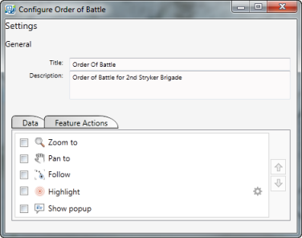
14. Click OK to create the Order of Battle

## Using the order of Battle Widget

Once configured the order of battle widget will display the features in a hierarchical tree view. The user is presented with a number of ways to interact with features in the order of battle widget.

### Configuring the selection mode

The Selection Mode governs the behavior of the Select Features and View Features tools in the toolbar. The check boxes allow the user to select or view the unit, subordinates, or both the unit and subordinates of the feature selected in the tree view. Furthermore, when the subordinate selection is chosen, the user may choose between immediate subordinates or all subordinate features by choosing the respective radio button. The selection mode is reflected in a banner at the top of the tree view to the right of the selection mode button. 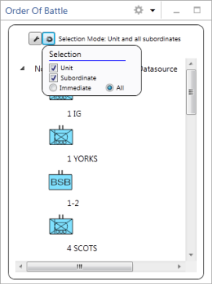

### Selection/View Toolbar

The selection and view toolbar contains a number of tools to work with feature selections and feature filters. 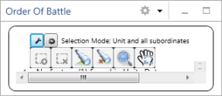

1. **Select Features**. Selects features determined by the feature selected in the treeview and the selection mode. For instance if the selection mode is units only, only the feature chosen in the tree view is selected. If the selection mode is units and all subordinates, the unit is selected and all features subordinate to it in the order of battle are selected.
2. **Clear selection**. clears all selections.
3. **View features**. Applies a filter to the features in the order of battle adhering to the selection mode. For example if the selection is units only, then the view features tool will display only the unit selected in the tree view.
4. **Clear View**. This tool removes the feature filter set by the View features tool.
5. **Zoom to Selected**. This tool zooms to features selected by the Select features tool, by setting the map extent to display all selected features.
6. **Pan to Selected**. This tool centers the map extent to the geographic center of the selected features without changing the map scale.